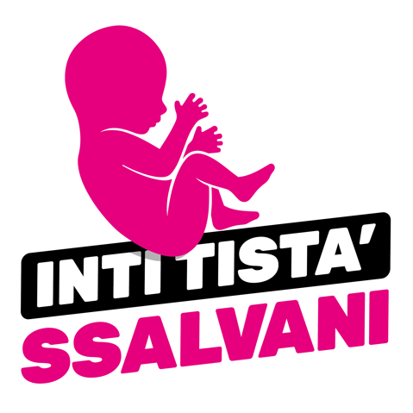
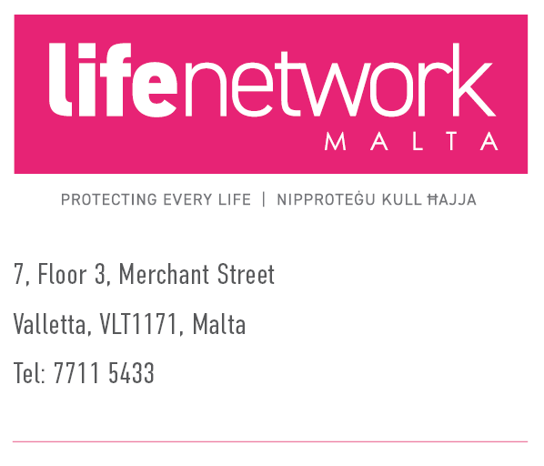
27nd November 2022
Press statement for immediate release
STOP ABORTION COMING TO MALTA
March for Life

The Life Network Foundation in collaboration with Doctors for Life and I See Life announce the holding of a national protest on the 4th December 2022 in front of Castille Square, Valletta at 3.00 pm.

The March is in support of the You Can Save Me (Int Tista Ssalvani) Campaign.
Government has presented an amendment to articles 241 and 243 of the Criminal Code, which as proposed opens the door for the introduction of abortion in Malta.
If the Government’s amendment becomes law, abortion will be allowed for any reason, because it “may” affect the mother’s health. This includes mental health. In the UK, one abortion happens every three minutes for “mental health” reasons.
We invite all the people of good will to join us in the protest and send a clear message to Government that Government has no mandate to introduce abortion, even less to do so by stealth.
Now is the time to stand up and be counted.
Int Tista Ssalvani
www.salvani.eu
ENDS
Press contact:
Dr Miriam Sciberras
(+356) 77115433
chairman@lifenetwork.eu

